**Active Subscription (e.g., for Microsoft Azure)**

1. **Go to** the provider's site (e.g., [azure.microsoft.com/free](https://azure.microsoft.com/free)).

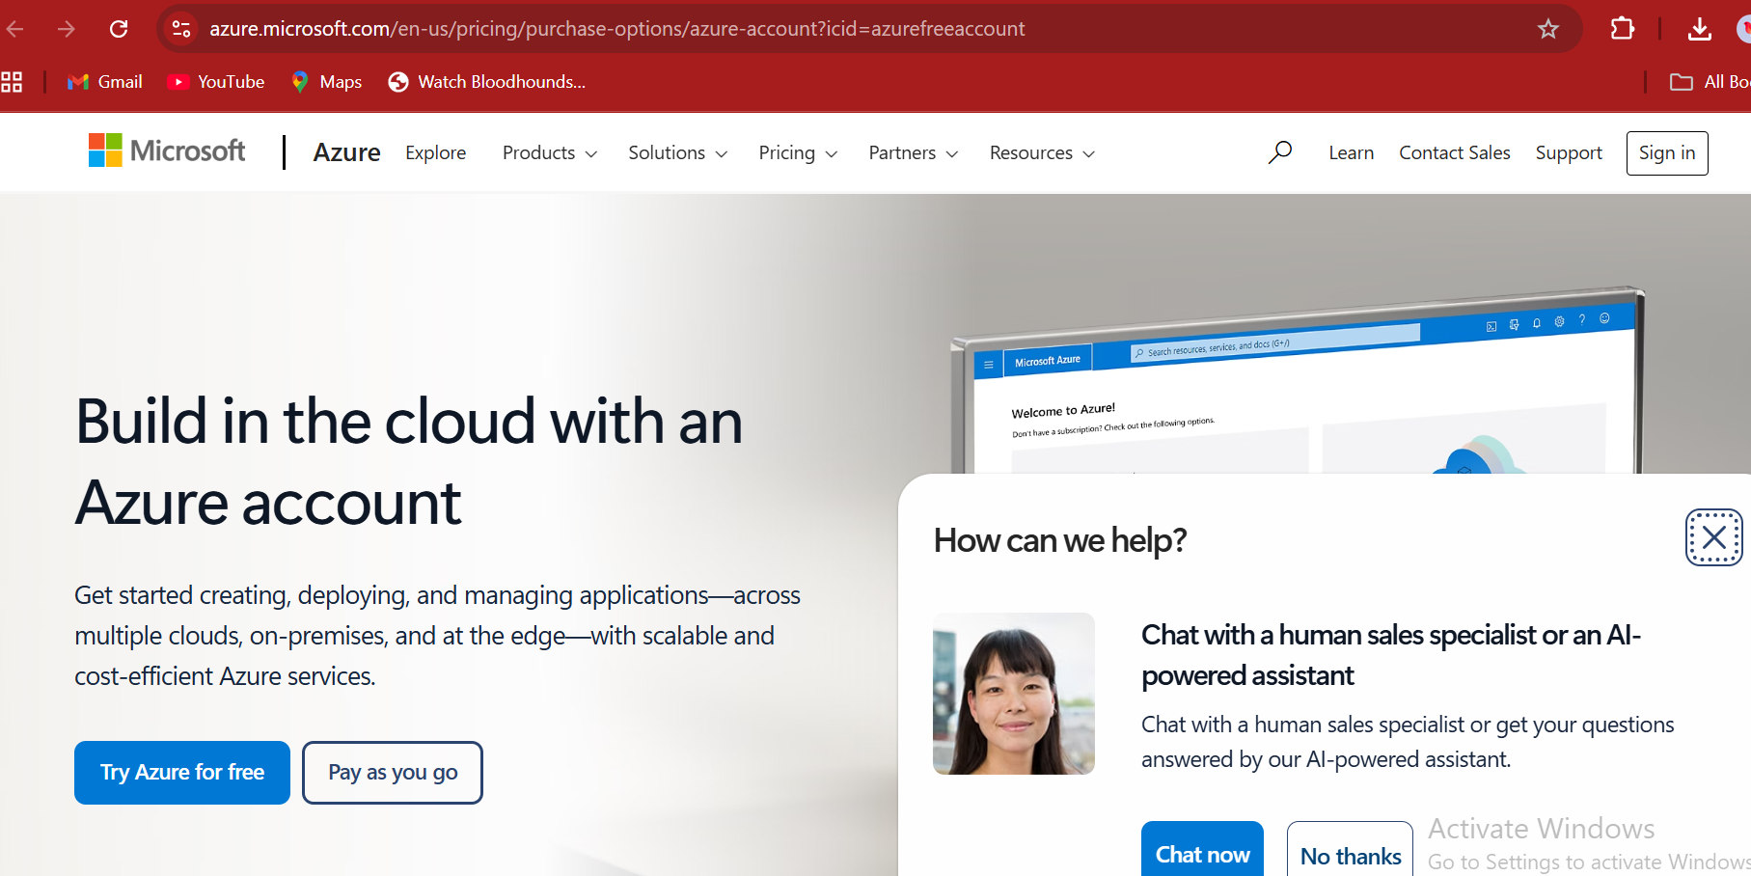

2)login or crete account

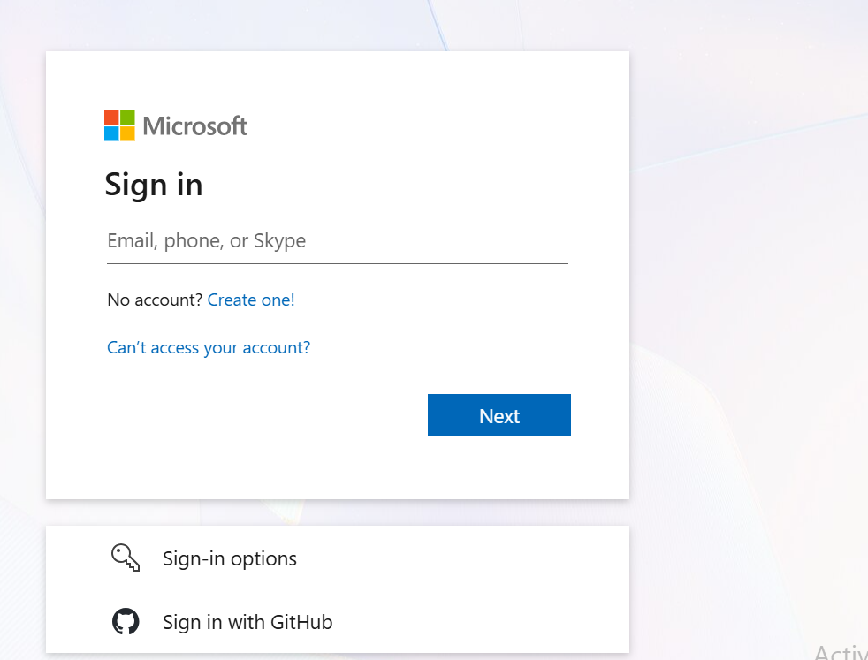

3)i loged in with github

